AWS Task-2

Task Description:

Set up a VPC with an Internet gateway, create a public subnet with 256 IP addresses, a private subnet with 256 IP addresses, make a route table connecting the Internet gateway and the subnets, and launch a Linux EC2 instance by using the above VPC and public subnet.

Output:-

AWS VPC Setup and EC2 Deployment

Steps performed: -

- Created custom VPC
- Added public and private subnets
- Attached Internet Gateway
- Configured route table for internet access
- Enabled public IP assignment
- Launched EC2 instance in public subnet
- Connected via SSH
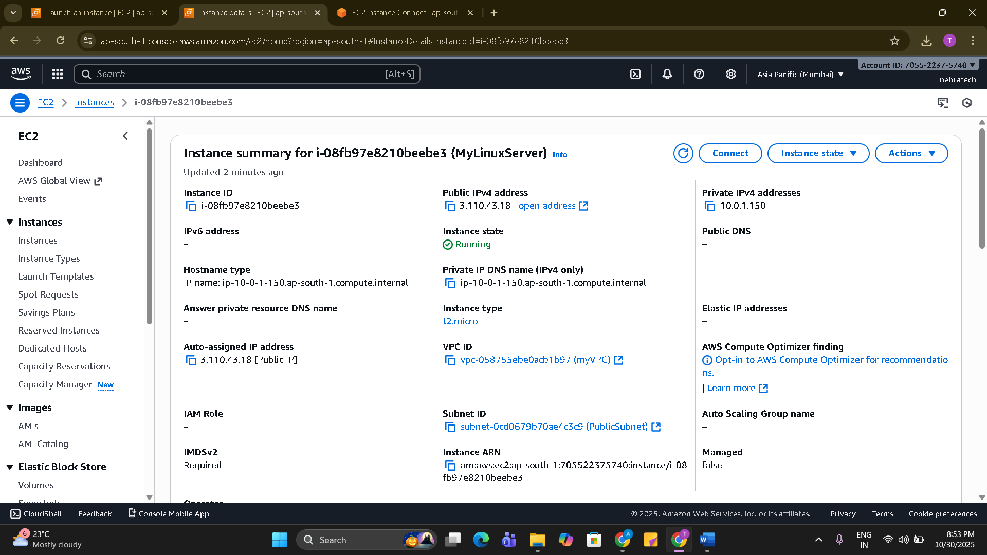

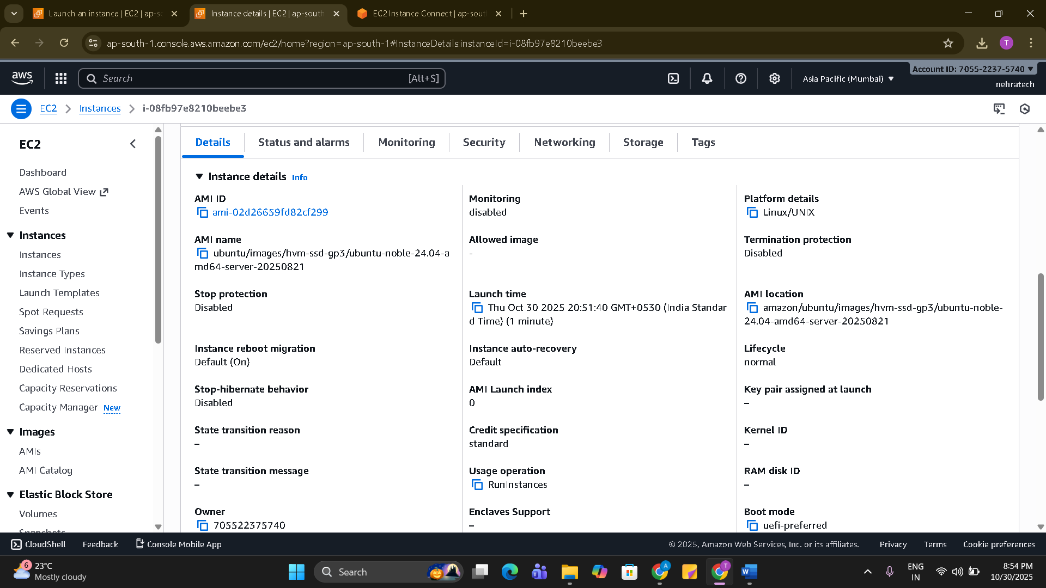

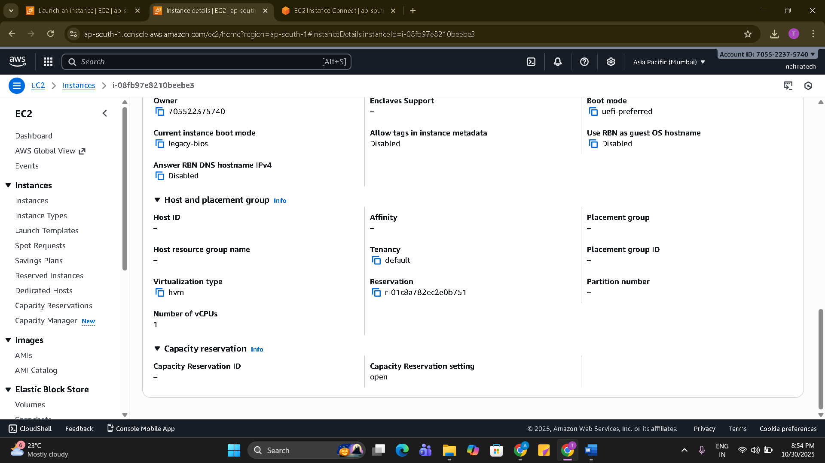

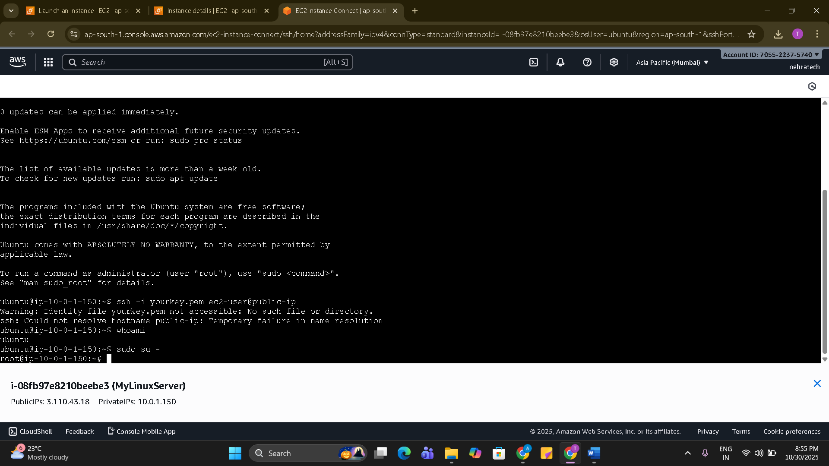

Techstacks needs to be used :

- AWS VPC
- AWS EC2

